**Submission Details**

1) Name of the team members, their contact and college details.

* Nishay Madhani [Third Year- Computer Engg. DJ Sanghvi College of Engineering]
* Harshil Jhaveri [Third Year- Computer Engg. DJ Sanghvi College of Engineering]
* Shreya Desai [Third Year- Computer Engg. DJ Sanghvi College of Engineering]

2) Name of the project - Waste Warrior : A Plastic Management System Powered by Blockchain and ML/CV

3) Idea/ Purpose of the project - We aim to digitise the process of Plastic Management using modern technologies like **Machine Learning, Computer Vision**, Supply Chain using **Blockchain**, Chatbots and Plastic Footprint Calculator for **Artificial Intelligence.**

We have used IBM’s Watson Visual Recognition Framework to analyse the images of waste uploaded by the user and **categorise** them into its method of disposal i.e. **Landfill, Compost and Recyclable**. Now according to its method of disposal we assign a monetary value in ‘Ether’ currency in Blockchain and then these currencies are transferred into their account using the supply chain concept.

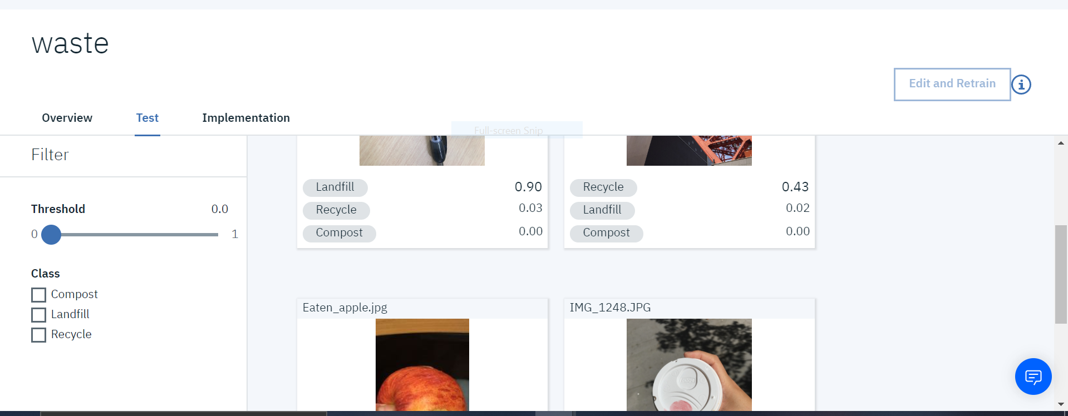

The user has three basic options for his waste: **Reduce,Recycle and Reuse.**

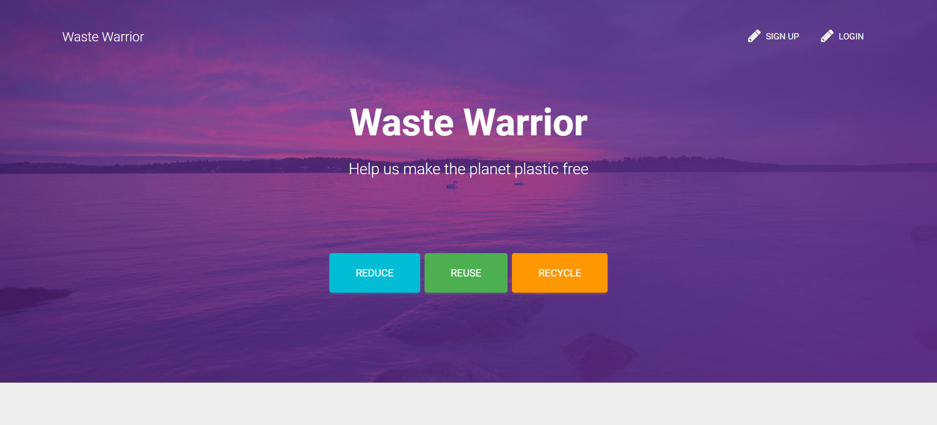

* **Reduce**:-The user then has an option to calculate his plastic footprints using his daily consumption of plastic products. There is also an Amazon Affiliate API that gives alternative eco friendly products to their normal plastic products.

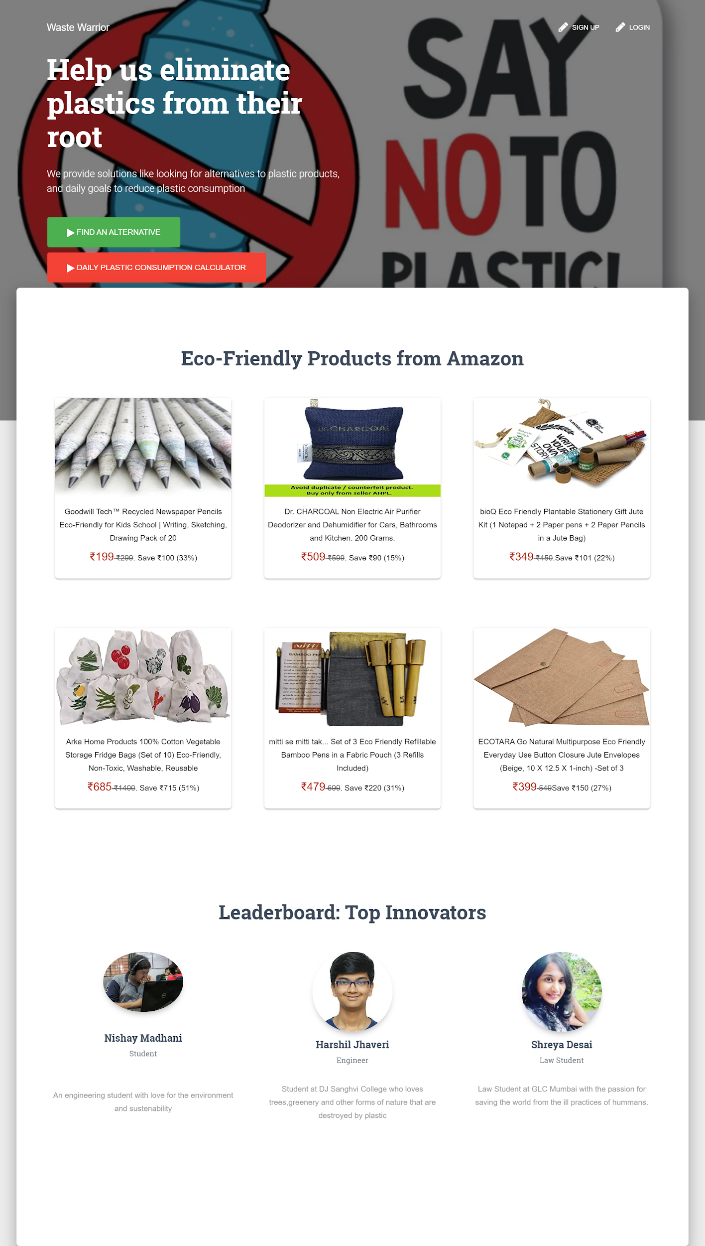

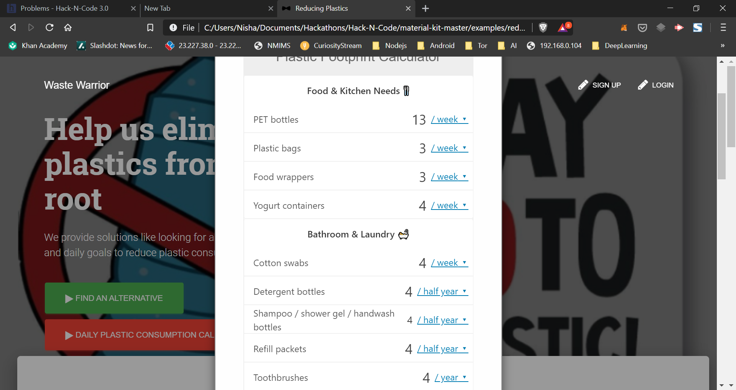

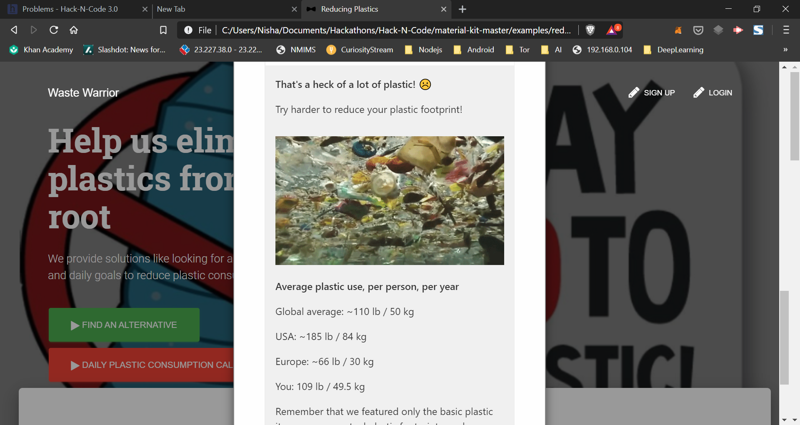

* Reuse :- Here the user is given two options i.e. to submit a spectacular and innovative plastic replacement solution that they may have andto donate in **‘Ethers’** to some innovators who have submitted their innovative ideas.

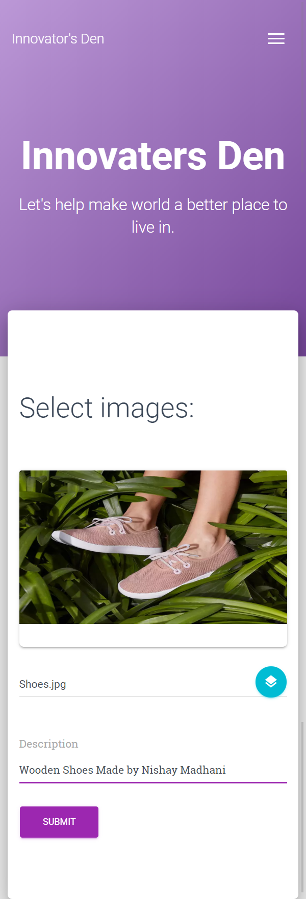

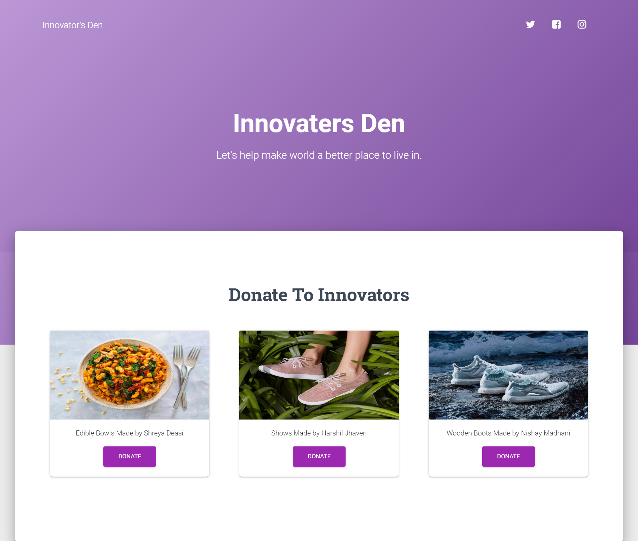

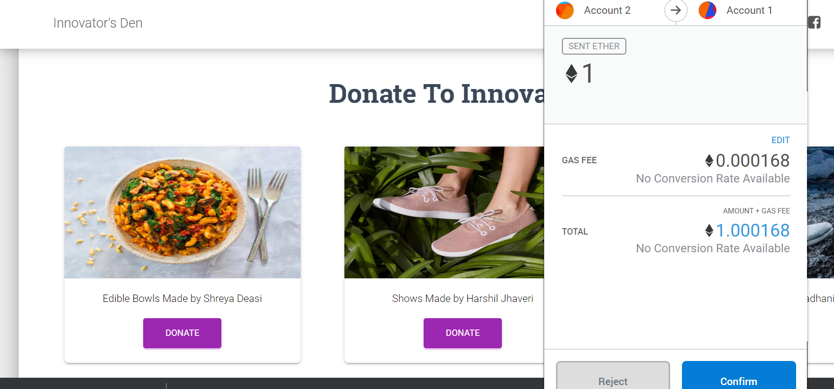

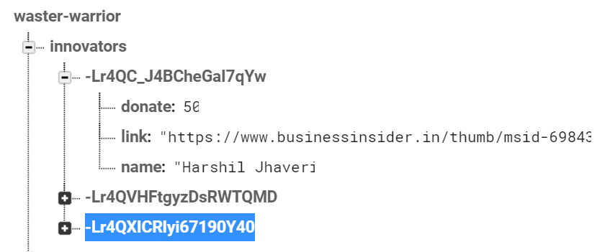

* Recycle :- Here he is given an interactive chatbot to use where he enters his geolocation using Google Maps API and other details like name,phone,email,etc. Based on location entered he is given nearest plastic deposition centers.

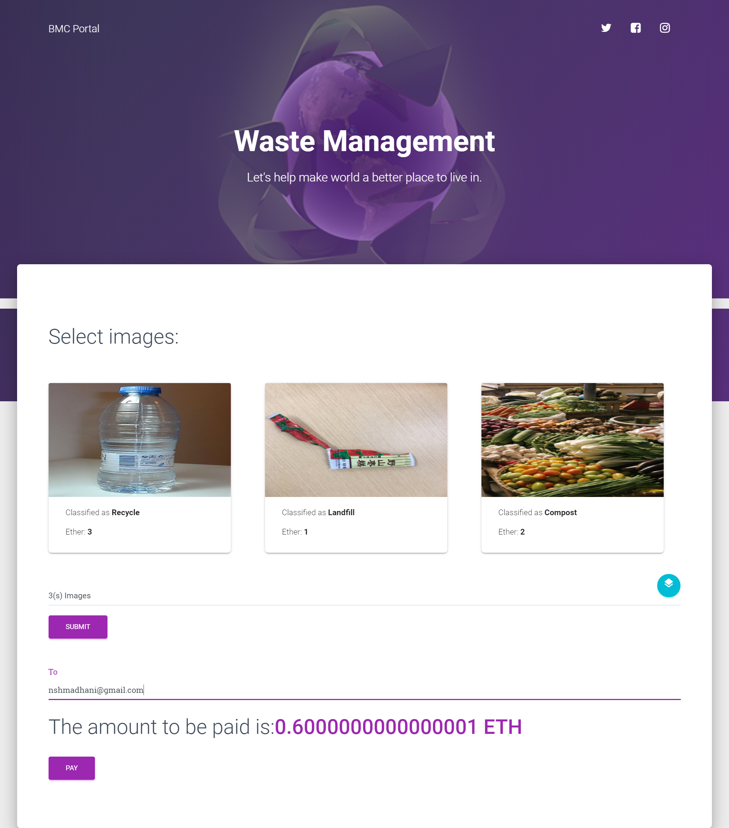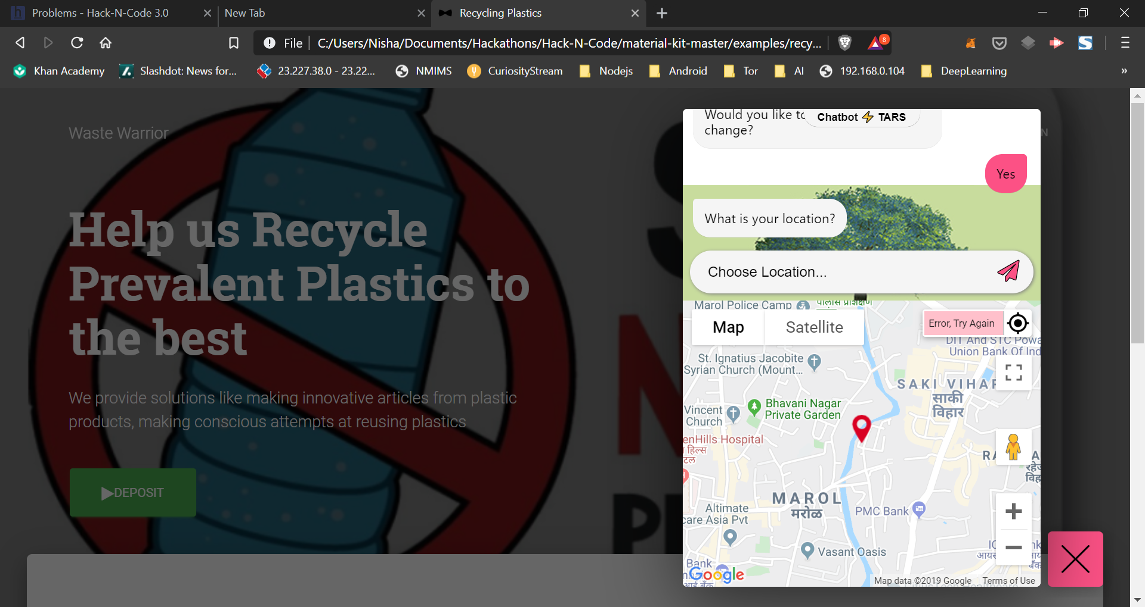

Above this each and every user is authenticated everytime he wishes to view certain deeper details.

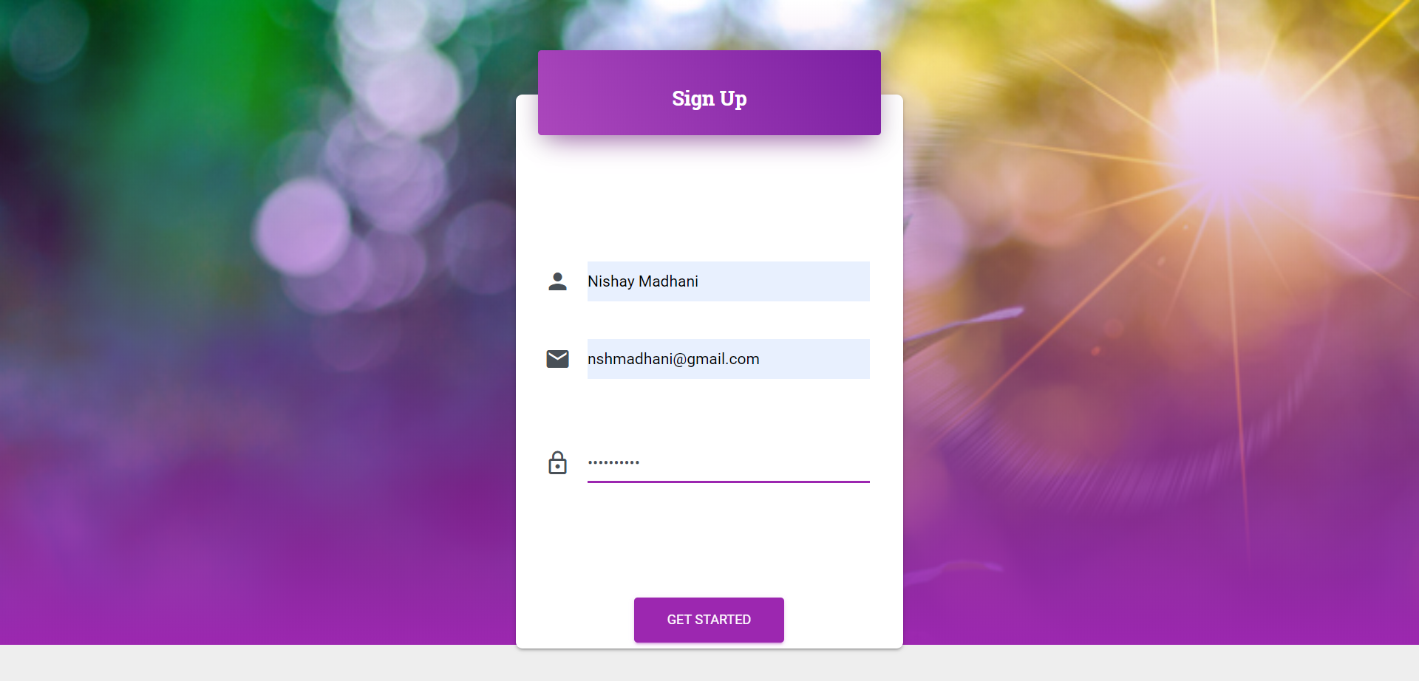

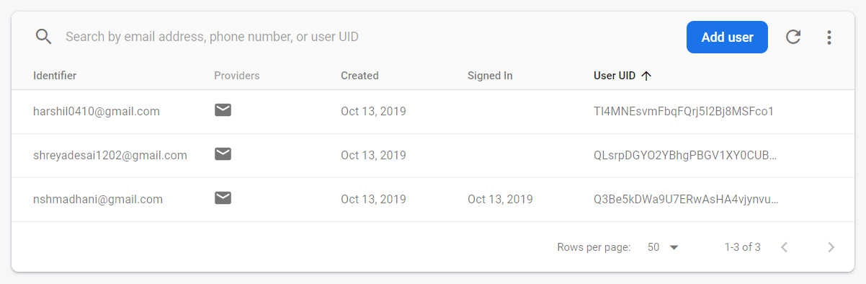

4) Technology implemented:-

* Machine Learning/ Computer Vision - **IBM Watson Framework**
* Blockchain - **Ganache,Ethereum,Solidity and Metamask**
* Frontend - Bootstrap, HTML, CSS, Material Design
* Backend - **Firebase** for Web

5) Future Scope and Scalability -

1. Our project has been made keeping in mind the alarming need for plastic management in the future.
2. We have used upcoming technologies like Computer Vision, Artificial Intelligence, Blockchain and Machine Learning.
3. For each sort of problem that arises we have a solution using upcoming methods.
4. For lazy citizens we have a chatbot that takes their details on their device and gives the closest dumping centers.
5. For careless citizens we are providing incentives of earning money in Ethers by depositing their plastic waste with us.
6. For inducing healthy competition between our innovators we provide them with badges and positions on the leaderboard for their sustainable ideas provided.
7. For an aware citizen there is an option to donate money in ‘Ethers’ to top innovators.
8. The most important application is to classify all plastic waste on basis of how it is to be disposed and assigning a value in ‘Ethers’ to it.
9. Another important application is giving citizens a count of the plastic footprints that they’re leaving behind based on their usage of day to day plastic material.
10. For the millenials we are using the Amazon Affiliate API to give eco friendly versions of their plastic articles that leads them to the AMAZON India page for the product.